UiPath Activities Manual SharePoint Custom Activities Package

-custom activities-

Table of Contents

Objective 4

Migration from .NET Framework to .NET 8 (Package Version=> 2.0.0) 4

Activities 4

1. SharePoint Activity Scope 4
   1. Description 5
   2. Parameters 5
   3. Test Connection 6
   4. Setup guide 7
2. SharePoint.Activities.Lists 12
   1. AddListItem 13
   2. Get List Items 16
   3. DeleteListItems 19
   4. UpdateListItems 20
   5. AddListItemAttachments 21
   6. GetListItemAttachments 22
   7. DeleteListItemAttachments 23
3. SharePoint.Activities.Libraries 23

Determining the Relative URL of a resource inside a library 24

* 1. CreateFolder 25
  2. Delete 25
  3. Get Children Names 26
  4. Get File 28
  5. Upload File 29
  6. Upload Large File 32
  7. Move Item 33
  8. Rename Item 35
  9. Check in File 35
  10. Check out File 35
  11. Discard check out 35

1. SharePoint.Activities.Users 36
   1. Create Group 36
   2. Delete Group 37
   3. Add User to Group 37
   4. Remove User From Group 38
   5. Get User 39
   6. Get All Users from Group 39
2. SharePoint.Activities.Permissions 41
   1. Add Permission 42
   2. Remove Permission 43
   3. Get All Permissions 44
3. Sign Out 47
4. Get Web Login User 48
5. Get TimeZone 48

Query Grouping 48

Example 49

Prerequisites 50

Observations 51

Technical Approach 52

# Objective

* Provide an integration between UiPath and SharePoint that permits the usage of the key functionalities of SharePoint that are most likely to be used in an automation.
* Allow document and folder management for Libraries.
* Allow CRUD functionalities on SharePoint Lists.
* Allow the creation/deletion of groups and the administration of the permissions assigned to them and of the users inside.
* Grouping the queries sent to SharePoint (whenever possible) so that we can do many requests in a relatively short amount of time.
* Give the user the option between multiple types of Authentication: Basic Auth, Interactive Authentication at Runtime, Azure App, SharePoint App Principals, etc.

# Migration from .NET Framework to .NET 8 (Package Version>= 2.0.0)

Read this if you are migrating from Package version <= 1.7 (Windows-Legacy) to version >= 2.0 (Windows ).

Version 2.0 marks a significant update where the project has been migrated from .NET Framework 4.6.2 to .NET 8. The integration now uses SharePoint REST API instead of the legacy Microsoft.SharePoint2016.CSOM runtime.

**Key Updates:**

* **Runtime Upgrade:**  
  Migrated from .NET Framework 4.6.2 to .NET 8 to enable Windows-Legacy RPA processes that depend on the old `UiPathTeam.SharePoint.Activity` to seamlessly transition to Windows projects.
* **API Transition:**  
  Replaced Microsoft.SharePoint2016.CSOM with the modern SharePoint REST API for better alignment with current web standards.
* **New Dependencies (auto resolved during package installation):**
  + Microsoft.AspNet.WebApi.Client (6.0.0)
  + Microsoft.Identity.Client (4.70.0)
  + Newtonsoft.Json (13.0.3)

**Testing & Production Readiness:**  
While extensive testing has been carried out on all activities, we strongly recommend that customers perform their own tests in a controlled environment prior to deploying to production. This ensures the new integration aligns perfectly with your specific workflows.

**Post-migration steps**

1. **Update Output Variable Type**

If any of the following activities are being used in the studio project, you will need to update the output variable type as follows:

|  |  |  |
| --- | --- | --- |
| Activity | Output Property | New Variable Type |
| Get User | SharePointUser | UiPathTeam.SharePoint.User |
| Get All Users From Group | Result | List< UiPathTeam.SharePoint.User> |
| Get web login user | SharePointUser | UiPathTeam.SharePoint.User |
| Get TimeZone | SharePointTimeZone | UiPathTeam.SharePoint.TimeZoneInfo |

Below is an example of updating the output variable of Get User activity:

1. **Remove and Retype output variable**

If your project is using ‘Get List Items’ activity, you **might** see some error icon on the activity. You can resolve it by simply emptying the output variable name of the activity, click Enter, and type/paste the variable name again.

1. **QueryGrouping Is Not Supported**

While testing **QueryGrouping** withthe old package version 1.7, it was noticed that QueryGrouping is functioning properly. Thus, we did not implement batching in the new packages since existing clients probably are not using it.

# Activities

### SharePoint Activity Scope

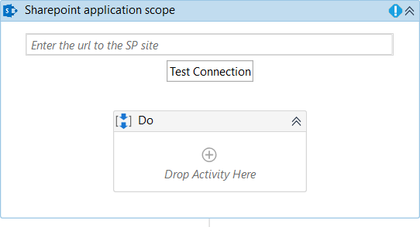

* 1. Description

This activity will be used as a container for all the other activities in the package. Its main purpose is to perform the authentication with the SharePoint site and to organize the queries sent by the other SharePoint activities (whether they are grouped together, or they are sent individually).

* 1. Parameters
* **URL:** The URL of the SharePoint site where we want to perform all our queries
  + All the SharePoint activities contained inside will be executed at the level of this site
* **UserName** & **Password/SecurePassword**: The credentials that should be used to connect to the site
  + You can choose between providing the password either as a simple String or as a SecureString. It is required to set the value only for one of them.
  + No need to provide the credentials here when using WebLogin or App-Only login type.
* **Login Mode:** A choice between **Online** (default)**, OnPremises, App-Only, WebLogin**(uses Sharepoint PnP, for MultiFactor Authentication) and **AzureApp**.
  + Based on the type of SharePoint instance you have, choose the appropriate value.

#### If the account or app used does not have the necessary permissions, some of the activities will throw exceptions.

* + **Online**: Basic Username and Password Authentication for SharePoint Online instances
  + **OnPremises:** Basic Username and Password Authentication for On-Premises SharePoint Server instances (especially useful if you are using an older version of SharePoint – like SharePoint 2013/2010, for example)
  + **WebLogin:** Authentication that opens a popup form for the user to introduce their credentials and waits for the second authentication factor to be solved (for example: approving the sign in request sent in a Microsoft Authenticator app, or use a verification code from a mobile app, etc). It remembers the set credentials for a period, so the user will not have to enter them every time, unless they choose to (by selecting **ResetCredentials** parameter in the activity).

#### Recommended only for Attended Robots

* + You should use **App-Only** for SharePoint sites for which you are able to create an **app-only principal** with tenant permissions, on which you can generate a **Client Id** and **Client Secret**. **You will use the two codes for logging in and the credentials are no longer required!**
  + **AzureApp** is a login mode that will use an Azure App to impersonate a specific user and perform actions on their behalf. It uses the **AzureApplicationID**, **AzureAppPermissions**, **Username** and **Password**/**SecurePassword** properties. **This login mode is only available for SharePoint Online instances only.**
* **QueryGrouping:** Option which the user can enable in order to specify that all the SharePoint queries done inside this activity scope should be executed at the end
  + This option allows us to more efficiently execute many requests in a relatively short amount of time (For example if you want to add 100 new items to a list, you can group all the queries in order to achieve better performance)
  + **Observation:** Using this option will only let you use the following activities inside this Scope: **AddListItem, AddPermission, RemovePermission, AddUserToGroup, CreateGroup, DeleteGroup, RemoveUserFromGroup.**
* **ClientId:** The Client Id generated for your site! Use it only when connecting using an app-only principal!
* **ClientSecret:** The Client Secret generated for your site! Use it only when connecting using an app-only principal!
* **LoginTimeout(miliseconds**): For **WebLogin**: the amount of time to wait for the user to enter the credentials and finish the Multifactor Authentication. The default is 300000(5 minutes). After this time, if the login is not performed, an exception will be thrown and the execution will end.
* **ResetCredentials:** For **WebLogin**: sign out the current user in order to enter new credentials (in case of MFA, the user might remain logged in for some time; if we need to log in a different user, we have to sign out the current one)
* **ClientContext:** an **out** argument of type Microsoft.SharePoint.Client.ClientContext that can be used to send requests to the SharePoint site in **Invoke Code** or **Invoke Method** activities.
* **PlatformType:** This property can be used to specify the type of SharePoint installation our activities are used with (either SharePoint Online or On-premises). This is relevant since depending on the type of platform, some activities can behave in a slightly different manner. Currently this only affects the **Upload Large Files** activity, but in future versions other activities might be impacted by it, too.
* **AzureAppId:** Used only with the AzureApp login mode, stores the Client ID of the Azure App
* **AzureAppPermissions:** Used only with the AzureApp login mode, can be used to configure the level of access allowed with the Azure App login
  1. Test Connection

A new button was added to the SharePoint Application Scope activity, that can be used to test the connection to your SharePoint site before runtime. The button opens the “**SharePoint Connection Test**” form in which the user needs to enter the credentials that they would use to connect to SharePoint. The form opens with the default values for the fields completed from the Activity’s settings.

Depending on the chosen Instance Type, the fields to complete differ:

* for **WebLogin**: Reset Credentials can be selected and the LoginTimeout can be set(no need for Username and Password to be set here, as the user will have to introduce them)
* for **Online** and **OnPremises**: Username and Password

#### for App-Only: Client ID and Client Secret

* for **AzureApp:** : Username, Password, **Azure App Id** and **Azure App Permissions**

The SharePoint URL is mandatory regardless of the SP Instance Type

**Observation:** You cannot use variables in the fields here, as we are not at runtime and their value cannot be computed

* 1. Setup guide
     1. *How to select the URL of your SharePoint site*

Whenever we try to interact with a SharePoint entity, we first need to figure out what site that entity belongs to, as **our activities function only in the scope of the SharePoint site given by the URL property.**

So, once we have a SharePoint resource, we need to figure out what the URL of our site is. To do that, you can simply navigate to the Homepage of the site:

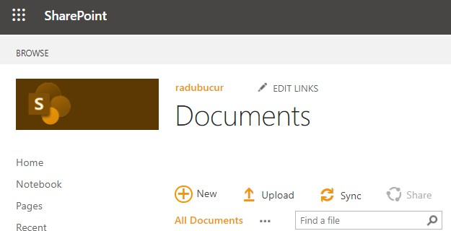

Once we are on the Homepage, we should look at our URL and extract only the Root of our site. The root is the part of the URL that remains constant, no matter what page of the site you’re on:



In my case, I’m on the Home.aspx page which is a file in the **SitePages** library in my site, so I will remove that part of the URL and keep everything before it and use that in my SharePoint Scope:

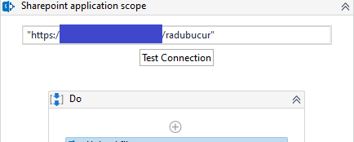

Keep in mind that if you want to use 2 SharePoint objects located on 2 different sites, using a different SharePoint Scope Activity with a different URL is necessary for each one of the objects.

**Observation:** SharePoint sites can have subsites and the root of a subsite will usually look like this **{parent site root URL}/{subsite name},** this could be a bit confusing if you’re unfamiliar with SharePoint but applying the rules described above should give you the correct root URL for both parent and child sites.

* + 1. *Configure the* ***App-Only*** *Login mode*

SharePoint App-Only authentication works for both Online and On-premises SharePoint installations and it involves the creation of an app entity with a Client ID and Client Secret called an **app-only principal** to which you can grant permissions to access SharePoint Sites and resources (like Lists, Libraries, Files, Folders, Groups, etc.).

Setting one up requires Admin Access to your SharePoint and is relatively straightforward but assigning the right permissions to your App Principal can be somewhat tricky the first time you do it. Still, the links below should provide you with all the information you need:

* + - * This is an in-depth guide on how an app-principal can be created: [https://docs.microsoft.com/en-us/sharepoint/dev/solution-guidance/security-apponly-](https://docs.microsoft.com/en-us/sharepoint/dev/solution-guidance/security-apponly-azureacs) [azureacs](https://docs.microsoft.com/en-us/sharepoint/dev/solution-guidance/security-apponly-azureacs)
      * This cheat sheet can be used to assign permissions to an App-Principal: [https://medium.com/ng-sp/sharepoint-add-in-permission-xml-cheat-sheet-](https://medium.com/ng-sp/sharepoint-add-in-permission-xml-cheat-sheet-64b87d8d7600) [64b87d8d7600](https://medium.com/ng-sp/sharepoint-add-in-permission-xml-cheat-sheet-64b87d8d7600)
    1. *Configure the* ***AzureApp*** *Login mode*

For SharePoint Online Instances it is possible to authenticate using an Azure App with delegated permissions and a user account. This means that you can create an App in your Azure Active Directory that will be allowed to perform operations on your SharePoint site on behalf of a specific user. To use this type of login, your SharePoint Scope needs to be provided with the App Client ID together with a Username and Password.

Setting up an Azure Active Directory App for the SharePoint activities package is largely similar to setting up an App it for the Office365 activities or the Exchange activities in the Standard Mail Activities package, so most of the steps are the same but some differences do exist:

1. Open you **Azure Portal** and go to the **Azure Active Directory**
2. Navigate to the App Registrations Section and click on **New application**

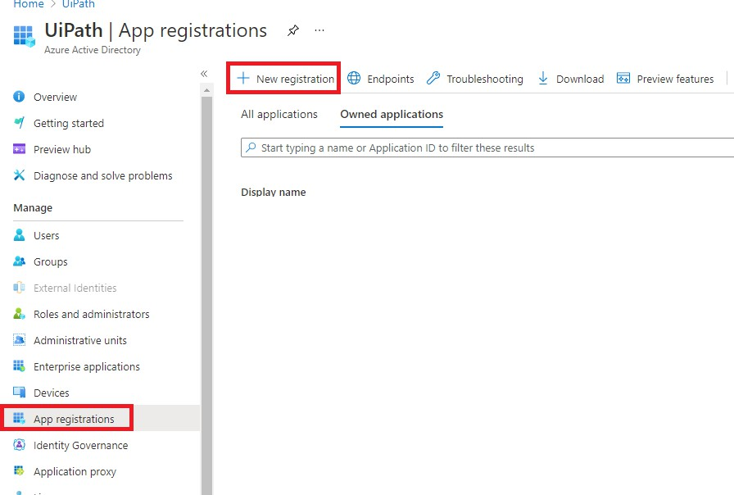

1. Give your App a name and choose the desired option for the supported account type. (Single Tenant if you want the app to be used only by users in your company or Multitenant if outside users should be able to use it too).
   1. Most of the time Single Tenant should be enough for RPA purposes
   2. If you’re finding it hard to decide, Azure has a section with detailed info about these 3 options

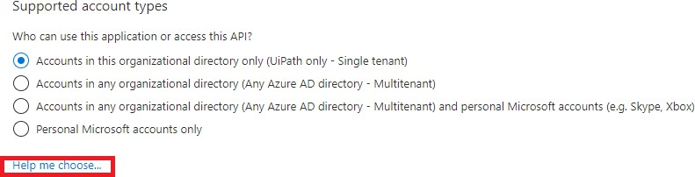

1. In the **Redirect URI** section, select the **Public client/native** and type

“https://login.microsoftonline.com/common/oauth2/nativeclient”

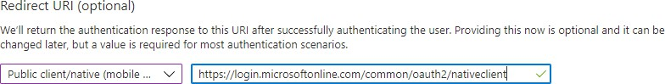

1. Click **Register**
2. After the App is created, open the Authentication Tab and enable Public Client Flows

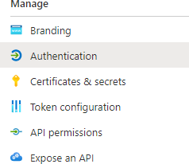

a.

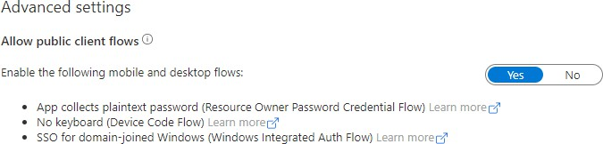

b.

1. Once your application is created, go to the Permissions screen and click **Add a permission**

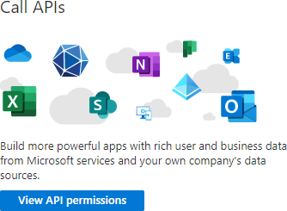

1. Find the SharePoint permissions and select **Delegated Permissions** and then select any of the 4 permissions: **Read**, **Write**, **Manage** and **Full** (depending on what type of access your automation needs)

a.

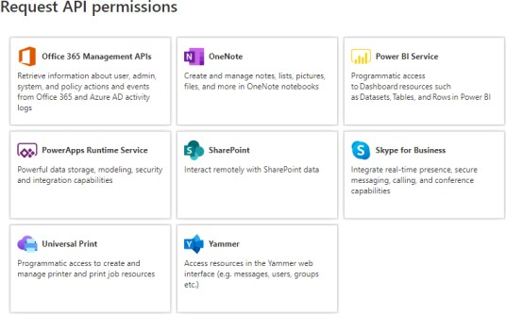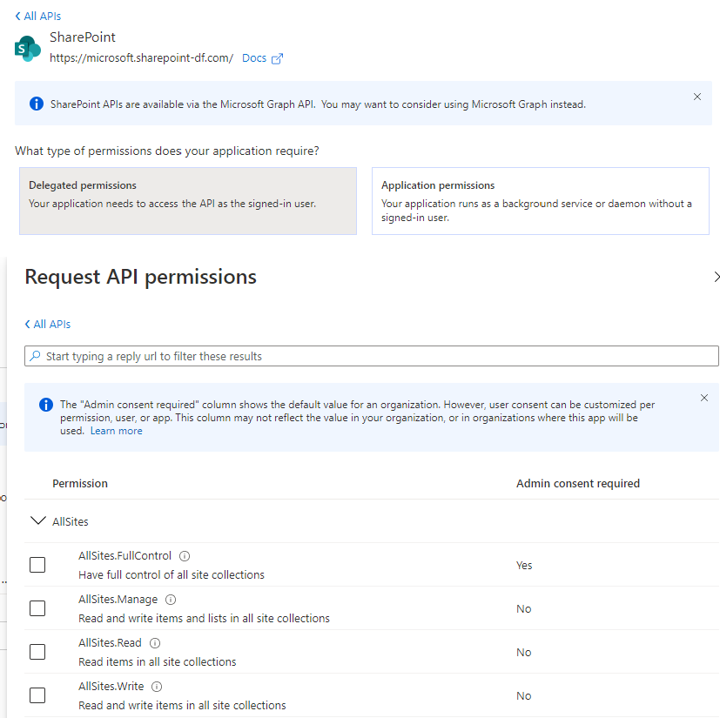

b.

c.

**Observation:**

For performing CRUD operations on List Items or Files: Read, Write and Manage permissions are enough. However, if you want to manage groups and permissions, you will need **FullControl** permissions (which will probably mean that Admin Consent will be needed).

1. Now we should be ready to configure our SharePoint Application Scope, for that, we need to copy the **Application (client) ID:**

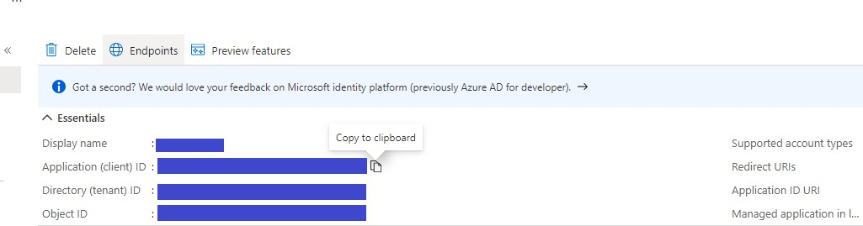

1. Simply fill in the URL, **AzureAppId**, **AzureAppPermissions, Username, Password** and **AzureAppPermissions** (make sure you select only permissions that have been given to the Azure App)

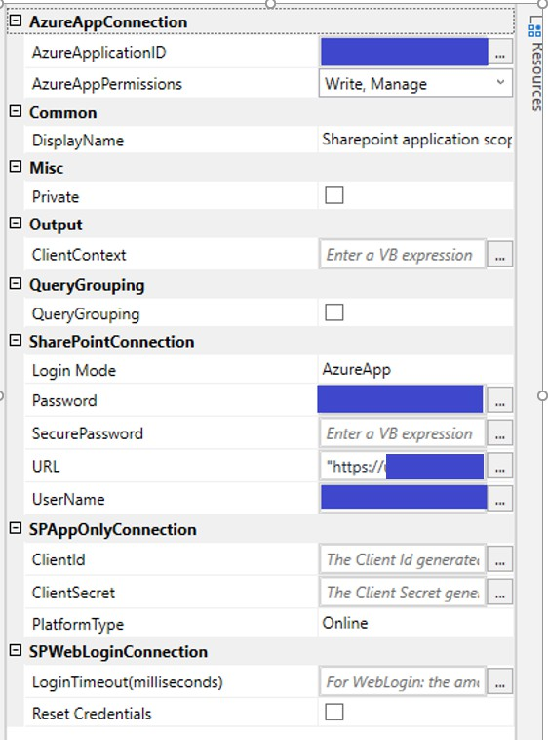

1. **(optional)** An admin of you Azure tenant can grant consent for your Azure App to be used with all users in your tenant, if that is not possible, see the next step.
2. If an Admin can’t (or most likely won’t) grant consent for the entire tenant to use this application, you will need to manually grant consent for the account you’re about to use. To do this, follow these steps:
   1. Click on the test connection button
   2. In the popup, set the Instance Type to **AzureApp** and fill in the **Azure App ID** and the **Permissions** fields. Make sure they match the permissions in the property **AzureAppPermissions** of the scope activity exactly!!

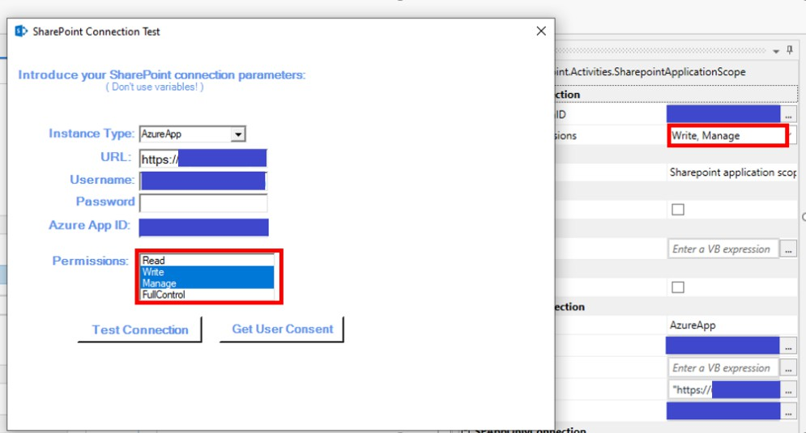

* 1. Click on **Get User Consent**. A popup will appear and you will have to login with the account you will use in the **SharePoint Scope.** Once you’re logged in, Click **Accept.**

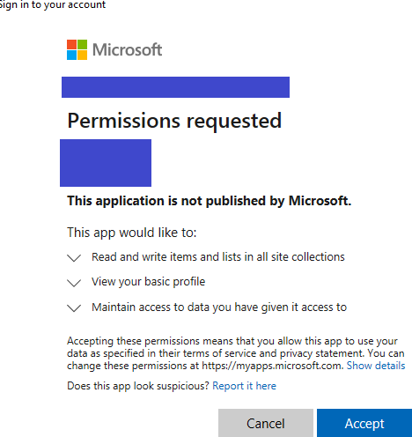

1. Now the activity is ready to be used

### SharePoint.Activities.Lists

A set of activities which provide the basic CRUD functionality for a SharePoint List:

* AddListItem
* GetListItems
* DeleteListItems
* UpdateListItems
* AddListItemAttachments
* GetListItemAttachments
* DeleteListItemAttachments
  1. AddListItem

This activity adds a **single** item to a SharePoint List located on the SharePoint Site specified in the parent SharePoint Scope Activity. Since adding items to a list can be a repetitive task, this activity can be used together with the **QueryGrouping** feature, in order to improve performance.

* + 1. *Parameters*
       - **ListName:** The name of the SharePoint List where we want to add the item
       - **PropertiesToAdd:** A **Dictionary<string, object>** object which should contain the values this list item should have. For each element in the dictionary, the **Key** is a string which represents the internal name a field has inside the SharePoint list and the **Value** is an object representing the actual value the newly added item will have inside that field.
       - **AddedItemID:** An **out** argument representing the ID of the newly added item.

#### If the QueryGrouping option is enabled, this argument will be null!

* + 1. *Example*

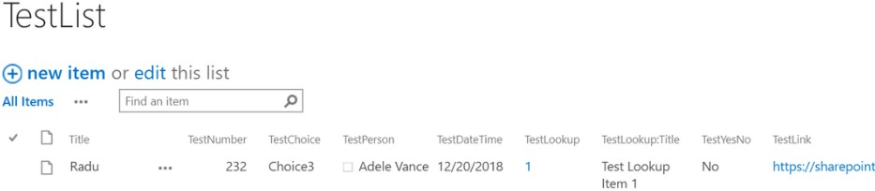A SharePoint List can have a multitude of data types so adding an item inside a list that makes use of all these data types can be challenging. In order to understand how we can do it, let’s try to add an item to the following list:

Now, let’s take a closer look at my list fields:

|  |
| --- |
| **Inside TestList we have the following data types** |
| C:\baf1a64a507727c970818900de0b02af |
| **This is a detailed explanation for all of them** |
| * **Title** is of type **Text**, so it is basically a plain string * **TestNumber** is a field of type **Number**, so in order to add a value here we will use an Int or a double value * **TestChoice** is of type **Choice**, so it is basically a string picked out of a predetermined set of values. If you go to your list's settings and open the field, you will find the options there. In my case, they are:   8547c4590b917108aeb81250c4a02ba6   * **TestPerson** is a column which simply hold a reference to a person, so we can set it using the Persons ID and a **Microsoft.SharePoint.Client.FieldUserValue.** The ID can be obtained using the **GetUserInformation** activity in this package. * **TestDateTime** is of type **Date and Time**, so we can add a value here by simply passing a datetime formated as a string * **TestLookup** is of type **Lookup** which is basically the way in which SharePoint implements associations (one-to-one, one-to-many and even many-to-many) between items in different lists. In order to add a value here, we have to pass the **ID** of the item we want to reference in one of the following two ways:   + either by wrapping it inside a **Microsoft.SharePoint.Client.FieldLookupValue** object like in the sample bellow   + or by setting the value of the field to a simple string in this format: "ID of the lookup";#"Title of the Lookup" (for example: **"1;#Title"** => takes the value of the column "Title" from the item with ID = 1.)   Just go to the list your lookup column is connected to and get the ID of the list item you want to be linked to |

|  |
| --- |
| * **TestLookup:Title** is secondary column that is configured to automatically display the title of the value being referenced in the primary lookup column. **So no need to set a value here!** * **TestYesNo** is basically a boolean value, so we can set it by passing either true or false * **TestLink** is a Hyperlink so we can set a value to this field by simply passing an url as a string |

In order to add a new item here, I will use the Add List Item activity in the following manner:

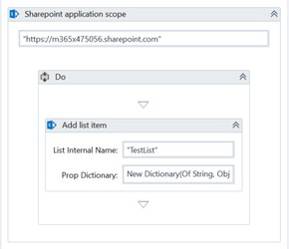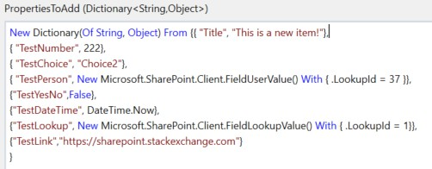

*(Note that the value for* ***TestLookup*** *can also be set like this: C:\Users\diana.mincu\AppData\Local\Microsoft\Windows\INetCache\Content.MSO\FBD011BC.tmp* *)*

After this workflow is executed, the following item appears in my List:

a84150afb3a89b061e7a7e1e5275d91c



**Observation!**

One important thing to keep in mind is that in order to reference these fields, we must use their **Internal Name,** not their title (often enough, they are not the same). In order to obtain the internal name of a field open the list settings, click the field and look at the URL of the page, the internal name will be there:

* 1. Get List Items

The **ReadListItems** activity has been renamed to **Get List Items** in the newest versions**.** This is an activity which uses the Collaborative Application Markup Language (**CAML** for short) to get a set of items from a SharePoint list, filtered on certain criteria.

CAML is complex but it is specifically designed for SharePoint so this means that we can create very powerful and precise queries. Furthermore, we can create these queries using 3rd party tools that generate CAML automatically, so there's no need to be an expert in order to use this activity. A good example of such a tool is SmartCAML, which is free in the Windows

store: <https://www.microsoft.com/en-us/p/smartcaml/9nn8gjpnxvfg>. If you want to learn CAML the hard way, you can check it out here: [https://docs.microsoft.com/en-](https://docs.microsoft.com/en-us/sharepoint/dev/schema/introduction-to-collaborative-application-markup-language-caml) [us/sharepoint/dev/schema/introduction-to-collaborative-application-markup-language-caml](https://docs.microsoft.com/en-us/sharepoint/dev/schema/introduction-to-collaborative-application-markup-language-caml).

This activity cannot be used with the Query Grouping feature enabled on the parent SharePoint Scope.

* + 1. *Parameters*
       - **ListName:** The name of the SharePoint List where we want to read items from
       - **CAMLQuery:** a string containing a valid CAML query that will be used to filter the specified list
       - **Items(Dictionary Array):** An **out** argument which will contain the returned items filtered using the CAMLQuery. It will be an array of **Dictionary<string, object>** objects.
       - **Items(DataTable):** An **out** argument which will contain the returned items filtered using the CAMLQuery, in a **DataTable** object, for an easier read of the returned items.

**Note!** We have created the Dictionary to Table extension method for **Dictionary<string, object>[]: ToDataTable,** so by installing this package you have access to the method that can **convert any array of (String, Object) Dictionary to a DataTable. :**

public static DataTable ToDataTable( this Dictionary<string, object>[] dictionary )

* + 1. *Example*

Let’s take the same list that we used for the Create List Item example and try to read some of its items.

My list currently looks like this:

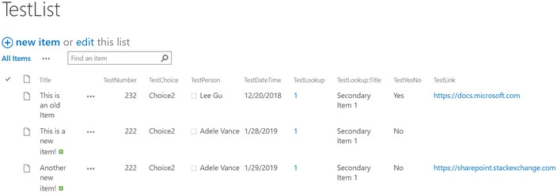

Let’s say that I want to extract all the items whose **Title** contain **"new"** and their **TestChoice** field contains **"Choice2".** I will use my SmartCAML ([https://www.microsoft.com/en-](https://www.microsoft.com/en-us/p/smartcaml/9nn8gjpnxvfg) [us/p/smartcaml/9nn8gjpnxvfg](https://www.microsoft.com/en-us/p/smartcaml/9nn8gjpnxvfg)) to quickly create these filtering options and then transfer them to my SharePoint activity:

|  |
| --- |
| **Query Configurations in SmartCAML** |
| 7b5da139d5eaafb112665d1a0708cf85 |
| **Resulting XML Query** |

|  |
| --- |
| C:\379fc194d641c30105afe6c230748f26 |
| **My query added to my Read List Items activity** |
|  |

I'll also add a ForEach to loop through all the results and a Writeline activity that will write the information from each item to the Output:

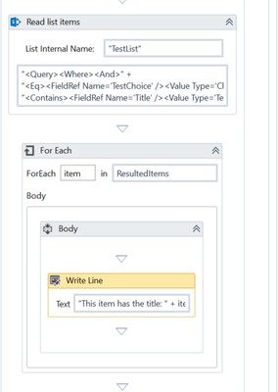

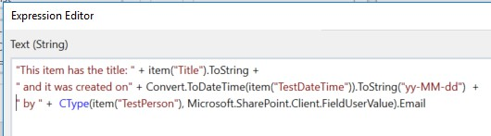

The output will be from the above flow will be:



* 1. DeleteListItems

This is an activity which uses the Collaborative Application Markup Language (**CAML** for short) to delete a set of items from a SharePoint list, filtered on certain criteria. This activity cannot be used with the Query Grouping feature enabled on the parent SharePoint Scope.

For an example on how to use a CAML query, read section 2.2 of this document.

* + 1. *Parameters*
       - **ListName:** The name of the SharePoint List where we want to delete items from
       - **CAMLQuery:** a string containing a valid CAML query that will be used to filter the specified list and retrieve the items that need to be deleted.
       - **AddedItemID:** An **out** argument representing the ID of the newly added item.

#### If the QueryGrouping option is enabled, this argument will be null!

* + - * **NumberOfRowsAffected:** An **out** argument of type **Int32** which will contain the number of items deleted using the CAMLQuery.
  1. UpdateListItems

This is an activity which uses the Collaborative Application Markup Language (**CAML** for short) to select a set of items from a SharePoint list, filtered on certain criteria and then update some of their fields using a dictionary containing all the properties to modify. This activity cannot be used with the Query Grouping feature enabled on the parent SharePoint Scope.

* + 1. *Parameters*
       - **ListName:** The name of the SharePoint List where we want to update the items
       - **CAMLQuery:** a string containing a valid CAML query that will be used to filter the specified list and retrieve the items that need to be updated.
       - **PropertiesToAdd:** A **Dictionary<string, object>** object which should contain the values we want to update. For each element in the dictionary, the **Key** is a string which

represents the internal name a field has inside the SharePoint list and the **Value** is an object representing the actual value we will use to update the items.

* + - * **AddedItemID:** An **out** argument representing the ID of the newly added item.

#### If the QueryGrouping option is enabled, this argument will be null!

* + - * **NumberOfRowsAffected:** An **out** argument of type **Int32** which will contain the number of items updated using the CAMLQuery.
    1. *Example*

Let’s take the same list that we used for the previous 2 examples and try to update some its items and let’s assume that I want to **change the Title of all the items that were created on January the 28th, 2019**. In this case, I will use the **Created** field (this is a field that is managed internally by SharePoint which contains the date on which the item was created and which is added automatically to all the Lists) to create the following CAML query:

#### CAML Query

"<Query><Where><And>" +

"<Geq><FieldRef Name='Created' /><Value Type='DateTime'>2019-01-28T00:00:00</Value></Geq>" + "<Leq><FieldRef Name='Created' /><Value Type='DateTime'>2019-01-28T23:59:59</Value></Leq>" + "</And></Where></Query>"

//basically, I want all the items older than 2019-01-28T23:59:59 and newer than 2019-01-28T00:00:00.

Since I want to update the title, I will use the following dictionary for the **PropertiesToAdd** dictionary:

#### CAML Query

New Dictionary(Of String, Object) From {{ "Title", "This item is now old."}}

Now, all the items from Created on that day will have the title: "This item is now old."

* 1. AddListItemAttachments

This is an activity that adds one or multiple attachments to a specified SharePoint list item

* + 1. *Parameters*

1. **ListName:** The name of the SharePoint List for which item we want to add the attachments
2. **ListItemID:** An argument of type **Int** which should contain the ID of the item for which we want to add the attachments
3. **Attachments:** Opens the argument editor dialog, which allows us to enter the full paths of the attachments, one by one
   * **AttachmentsCollection:** An argument of type IEnumerable<String> which contains the array of strings corresponding to the full paths of the attachments

**Observation**:

We can mention attachments names both in Attachments and AttachmentsCollection and they will all be added

* + 1. *Examples*

Let’s try to add some files as attachments to the first item in “DianaList" in SharePoint.

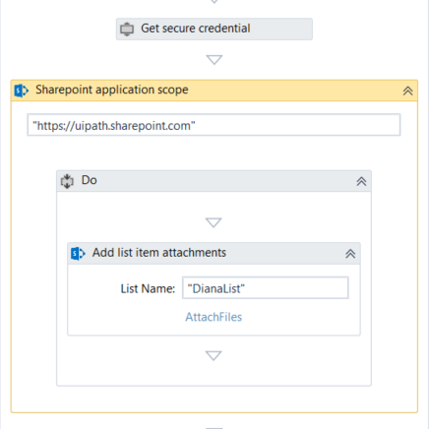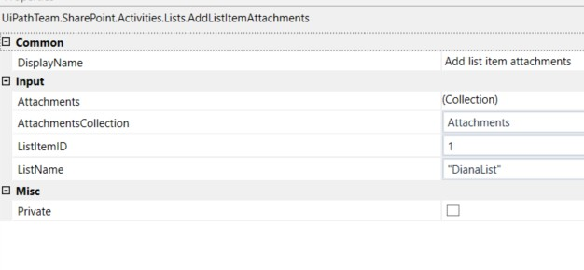

We have to set the ListItemID to 1 (for the first item in the List).

The **AttachmentsCollection** parameter is set to a string[] variable. Note the strings used to initiliaze it: they contain the path and the full name of the files to attach:

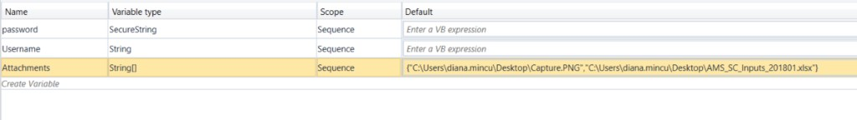

In the Arguments Editor dialog that is opened trough the Arguments parameter, we specify one more file :

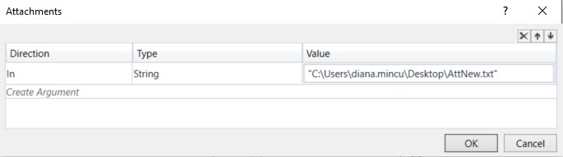

Run the workflow and notice the Attachments Properties of the List Item, before and after the Add:

|  |  |
| --- | --- |
| Before | After |
| C:\Users\diana.mincu\AppData\Local\Microsoft\Windows\INetCache\Content.MSO\8A663EF0.tmp | C:\Users\diana.mincu\AppData\Local\Microsoft\Windows\INetCache\Content.MSO\70B7327E.tmp |

* 1. GetListItemAttachments

This is an activity which gets the attachment names from a SharePoint list item.

* + 1. *Parameters*
       - **ListName:** The name of the SharePoint List where we want to update the items
       - **ListItemID:** An argument of type **Int** which should contain the ID of the item for which we want to retrieve the Attachment Names.
       - **AttachmentNames:** An OutArgument of type **string[]**. Which contains the file names of all the attachments of the current item

**Observation**:

In order to download the attachments, use the **Get File** activity and the following URL: **/Lists/{ListName}/Attachments/{Item ID}/{Attachment name}**

* 1. DeleteListItemAttachments

This is an activity which deletes one or multiple attachments from a SharePoint list item.

* + 1. *Parameters*
       - **ListName:** The name of the SharePoint List for which item we want to delete the attachments
       - **ListItemID:** An argument of type **Int** which should contain the ID of the item for which we want to delete the attachments
       - **Attachments:** Opens the argument editor dialog, which allows us to enter the names of the attachments as they are found in SharePoint, one by one
       - **AttachmentsCollection:** An argument of type IEnumerable<String> which contains the array of strings corresponding to the names of the attachments as they are found in SharePoint
       - **DeletedAttachmentsNr:**An **out** argument that returns the number of deleted attachments

**Observation**:

We can mention attachments names both in Attachments and AttachmentsCollection and they will all be deleted

### SharePoint.Activities.Libraries

A set of activities which can be used for basic operations on files and folders in a SharePoint Library:

* CreateFolder
* Delete
* GetChildrenNames
* GetFile
* UploadFile
* MoveItem
* RenameItem
* Check In File
* Check Out File
* Discard check out

These activities provide a way of handling files and folders inside a specific SharePoint Site. Generally, we can reference these files and folders by using their relative URL.

These activities are not compatible with the **QueryGrouping** feature; therefore, they cannot be used if this feature is enabled in their SharePoint Scope.

Determining the Relative URL of a resource inside a library

In order to use these activities, we need to determine the relative path of the libraries, folders and files we want to use. Usually these paths have the following format:

/{relative site url}/{library}/{folder path inside the library}/{file name} (**the relative site url** is optional)

#### OR

**/{library}/{folder path inside the library}/{file name} if our site is the root of the site collection**

For the **relative site URL** and the **library** part you should navigate to the library page in SharePoint and check the URL:

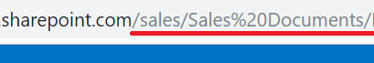

That means that the URL for the library is: **/sales/Sales Documents/** (**the relative site url** is optional)

The **folder Path** can be easily calculated by concatenating the names of all the folder containing our target, starting from the top-most container and going all the way to the direct parent of our current target and simply adding **"/"** between them.

Also, the path of a document/folder can be retrieved by expanding its menu and copying the link and selecting the relative url (from the "[sharepoint.com/](http://sharepoint.com/)" until the **"?"** and decoding it)

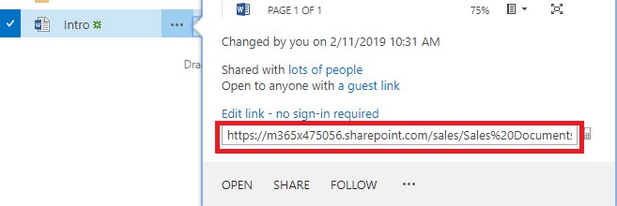

c4185cc90f719ffd048862506d9c94f7

So, for the above example, I will get the URL: **/sales/Sales Documents/Intro.docx**, if I remove the optional relative site url, I get **/Sales Documents/Intro.docx.**

* 1. CreateFolder

This activity adds a new folder in a library, at the specified path. It creates nested folders as well.

* + 1. *Parameters*
       - **LibraryName:** the name of the Library in which the folder will be created
       - **RelativeUrl:** the url relative to the Library of the new folder. If one folder in the specified URL doesn't exist, the activity creates it.
  1. Delete

The activity can be used to delete any file or folder in a Library.

* + 1. *Parameters*
       - **Library name:** The name of the library where the resource we want to delete is located
       - **RelativeUrl:** The relative URL of the file/folder that will be deleted **(relative to the library)**
       - **AllowOperarionsOnASPXFiles:** Check this box if you want to change the webpages of the application itself (pages like Home.aspx, etc. are simply files that are stored in special libraries that can be managed through these activities). Unless this box is checked, deleting ASPX files will result in an exception.
    2. *Example*

The sample bellow will delete the "Samples.docx" file from the root folder of the "**Documents**" Library.

Here's the document:

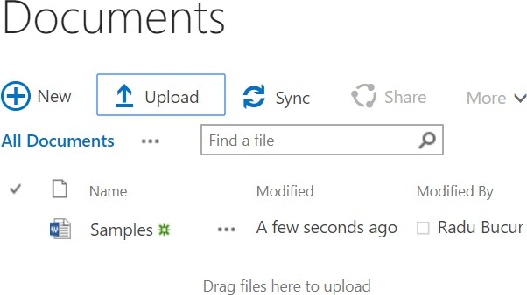

And this is the code:

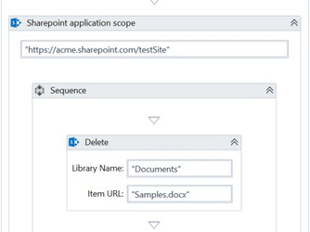

The Item URL relative to the library would be: **“Samples.docx"**

* 1. Get Children Names

The activity returns an array containing the **direct** children names (both folders and files) of a specified folder.

* + 1. *Parameters*
       - **RelativeUrl:** The relative URL of the parent folder
       - **ChildrenNames:** an **OUT** argument of type String[] with the children names
    2. *Examples*

Suppose we need a list with all direct children of a specific folder in our library **Sales Documents.**

The snippet bellow should do the trick. It will provide us with all the names of the items found in the root folder of the "**Sales Documents**" library:

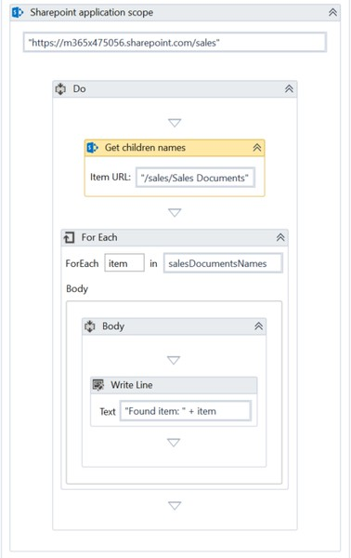

We have to create a String[] variable (in this case salesDocumentsNames) which will be the output of our activity (as shown in the Properties panel) and will store the array of children names.

|  |  |
| --- | --- |
| **Library folder structure** | **Activity output** |

|  |  |
| --- | --- |
| f389574efbd9cc8c9564a271e6b5f868 | c9c36e823b317840e082a468502bde5f |

* 1. Get File

An activity that downloads a file from a specified URL into the mentioned local path.

* + 1. *Parameters*
       - **LocalPath:** Local path where the file will be saved. If it doesn't contain the name that the file will have locally, the name the file has on SharePoint will be used
       - **RelativeUrl:** The relative URL of the file which will be saved
    2. *Example*

Here is a sample of using the GetFile activity to download the "Expenses.xlsx" file from the "TestFolder" folder of the Documents library.

The snippet that does this job it would be:

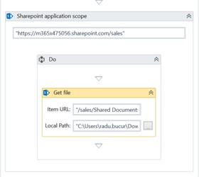 \

The SharePoint Item URL is: **"/Shared Documents/TestFolder/Expenses.xlsx".** The local path is my Downloads folder.

#### From SharePoint:

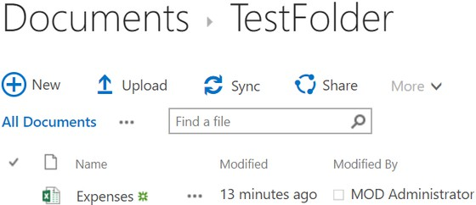

**Into the local path:**



* 1. Upload File

An activity that uploads a file at a specified URL in a Library, from the mentioned local path and adds a set of field values to it.

This will upload the file in the exact path specified in the Item Url. If we don't specify the name the file will have in SharePoint, it will be given the name it initially had locally.

If uploading bigger files is needed, use the **Upload Large File** activity instead.

* + 1. *Parameters*
       - **LocalPath:** The current local path and name of the file to upload
       - **RelativeUrl:** The relative URL where the file will be uploaded and its name
       - **PropertiesToAdd:** An argument of type **Dictionary<string, object>** that represents a collection of values to be added to the field values of the library for the newly added document. For each element in the dictionary, the **Key** is a string which represents the internal name a field has inside the SharePoint list and the **Value** is an object representing the actual value the newly added document will have inside that field.
       - **AllowOverwrite:** Checkbox which specifies whether or not we should let the robot override an existing file with the same Relative URL. Enabled by Default.
       - **AllowOperarionsOnASPXFiles:** Check this box if you want to change the webpages of the application itself (pages like Home.aspx, etc. are simply files that are stored in special libraries that can be managed through these activities). Unless this box is checked, uploading ASPX files will result in an exception.
       - **CheckOutFileBeforeOverwrite:** If there's already a file with the same name at the specified SharePoint location, having this checkbox checked will tell the activity to first check out the file before we overwrite it. Otherwise, no effect.
       - **CheckInFileAfterCreation:** If this checkbox is checked, then the robot will attempt to check in the file after it has been uploaded to the server. If the file is not checked out after the upload, no effect

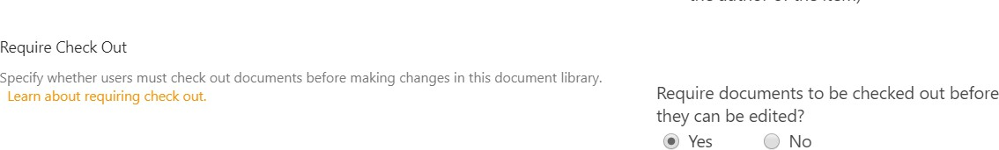



**Observation:**

* If an in-depth example is needed on how to add metadata to a Library Item, check the example provided for the **Add List Item** activity.
* If the metadata needs to be edited the **Update List Items** Activity can be used!
* he "**Require Check Out**" option (located in the Versioning Section of the Library Settings) will not let users modify files unless they are checked out. Additionally, because of this option, any new files uploaded to be checked out by default. In order to mitigate this setting, you can enable the properties: **CheckInFileAfterCreation** and **CheckOutFileBeforeOverwrite**
* **CheckInFileAfterCreation** and **CheckOutFileBeforeOverwrite** will cause one extra query to be made, so the activity will be a bit slower. Do not use them unless necessary.
  + 1. *Example*

Let’s assume that my Documents library has a text field called **Additional Info** and another field called **Responsible** where the current person that is responsible for the document is added:

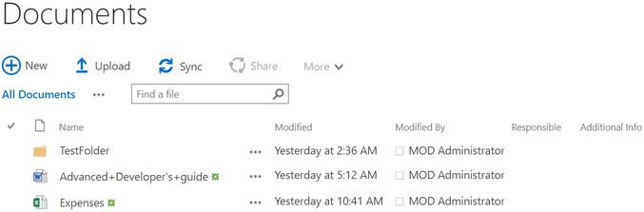

Let’s try to upload a file called ExportedContractsTable.xlsx to the test folder of the Documents Library. When we upload the document to this library, we would like to add values to both fields filled with values, so we will add the values to the **PropertiesToAdd** dictionary:

#### Properties Dictionary

/* the FieldUserValue is initialized with the ID of the user*/ New Dictionary(Of String, Object) From {

{ "Additional_x0020_Info", "This is a short summary of the document"},

{ "Responsible", New Microsoft.SharePoint.Client.FieldUserValue() With { .LookupId = 37 }}

}

The snippets that uploads the file will look something like this:

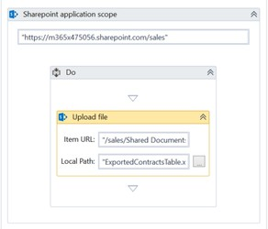

The Item URL is: **“/Shared Documents/TestFolder"**

The result will be:

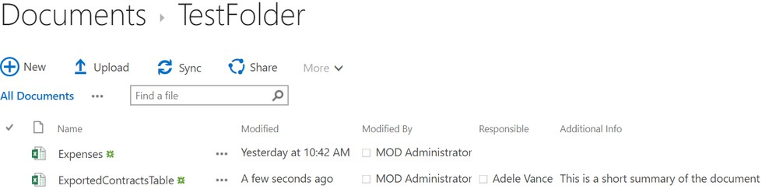

* 1. Upload Large File

An activity very similar to the **Upload File** activity, designed to upload very large files (over 100 Mb).

The parameters used by this activity are the same as with Upload File, but this activity uses a different approach to upload files, depending on the type of SharePoint Platform and the authentication method, so there could be small variations in the performance and error messages depending on your instance.

**Observation:**

This activity currently does not support the combination of **App-Only** Authentication and On- Premises SharePoint **Server**.

* + 1. *Parameters*
       - **LocalPath:** The current local path and name of the file to upload
       - **RelativeUrl:** The relative URL where the file will be uploaded and its name
       - **PropertiesToAdd:** An argument of type **Dictionary<string, object>** that represents a collection of values to be added to the field values of the library for the newly added document. For each element in the dictionary, the **Key** is a string which represents the internal name a field has inside the SharePoint list and the **Value** is an object representing the actual value the newly added document will have inside that field.
       - **AllowOverwrite:** Checkbox which specifies whether we should let the robot override an existing file with the same Relative URL. Enabled by Default.
       - **AllowOperarionsOnASPXFiles:** Check this box if you want to change the webpages of the application itself (pages like Home.aspx, etc. are simply files that are stored in special libraries that can be managed through these activities). Unless this box is checked, uploading ASPX files will result in an exception.
       - **CheckOutFileBeforeOverwrite:** If there's already a file with the same name at the specified SharePoint location, having this checkbox checked will tell the activity to first check out the file before we overwrite it. Otherwise, no effect.
       - **CheckInFileAfterCreation:** If this checkbox is checked, then the robot will attempt to check in the file after it has been uploaded to the server. If the file is not checked out after the upload, no effect
  1. Move Item

An activity that moves a file or folder from a specified URL in a Library, to another URL, either in the same Library or another one.

In the case of folders, they will be moved along with all their contents.

* + 1. *Parameters*
       - **RelativeUrl:** The relative URL of the file/folder that will be moved
       - **DestinationRelativeUrl: The relative URL of the Folder/library** where the file/folder will be moved
       - **AllowOverwrite:** Checkbox which specifies whether or not we should let the robot override a file with the same name already located at the Destination URL. Enabled by Default.
    2. *Example*

Let’s assume that inside my Sales site I want to move the **Sales Related Documents** folder from the **Documents** library to the Miscellaneous folder inside the **Sales Documents** library.

Folder to be moved:

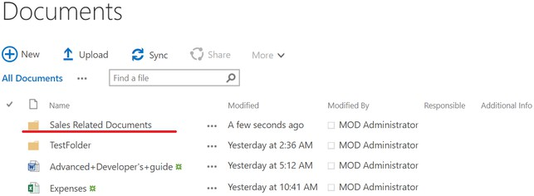

Destination:

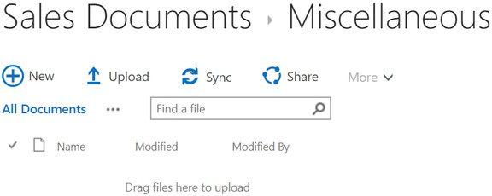

The snippet of code that achieves this:

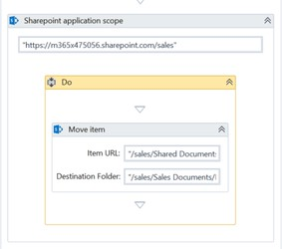

The Source URL: **//Shared Documents/Sales Related Documents** and the Destination URL: **/Sales Documents/Miscellaneous.**

Result:

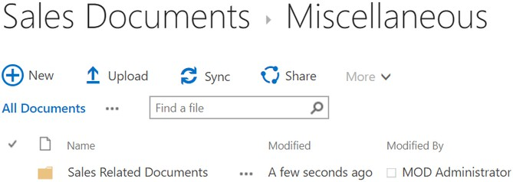

* 1. Rename Item

An activity that changes the name of a file of folder from a specified URL in a Library.

* + 1. *Parameters*
       - **RelativeUrl:** The relative URL of the file/folder that will be renamed.
       - **NewName:** The new name of the file/folder
  1. Check in File

An activity that checks in a file from a specified URL. If the file is not checked out, nothing happens.

* + 1. *Parameters*
       - **RelativeUrl:** The relative URL of the file
  1. Check out File

An activity that checks out a file from a specified URL. If the file is already checked out, an exception will occur.

* + 1. *Parameters*
       - **RelativeUrl:** The relative URL of the file
  1. Discard check out

An activity that discards the check out of a file from a specified URL. If the file is not checked out, an exception will occur.

* + 1. *Parameters*
       - **RelativeUrl:** The relative URL of the file

### SharePoint.Activities.Users

Groups are very important in SharePoint, they can be given permissions to read/edit/create/delete certain items, folders, lists libraries and even sites. They also have secondary purposes, serving as mailing lists, etc. SharePoint Groups can contain users and even AD groups, thus making managing permissions through groups very easy.

To check the current groups your Site has and their members, you should click the "Users and Groups" link inside the **Site Settings:**

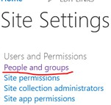

This package contains a set of activities which can be used in order to create and delete user groups, as well as add and/or remove users from them:

* AddUsersToGroup
* CreateUserGroup
* RemoveGroup
* RemoveUserFromGroup
* GetUser
* GetAllUsersInsideGroup

All these activities can be used together with the **QueryGrouping** feature, except

#### GetAllUsersFromGroup and GetUserInformation.

* 1. Create Group

This is an activity that creates a group on the site referenced by the SharePoint Application Scope.

* + 1. *Parameters*
       - **GroupName:** The name of the group we're about to create
       - **GroupDescription:** A description for the group
  1. Delete Group

Deletes one of the groups on your SharePoint Site.

* + 1. *Parameters*
       - **GroupName:** The name of the group we're about to delete
  1. Add User to Group

Adds a user to a specific group. This also works with AD groups since in SharePoint they are pretty much treated just like users are.

* + 1. *Parameters*
       - **GroupName:** The name of the group we're adding the user to
       - **User**: The users email or "{domain}\{username}" or the name of an AD Group
    2. *Example*

Let’s assume we want to create a group and add 2 users to it, a regular user, which we will reference using their email address and an AD Group called **Everyone.**

We will add the regular user to the group by referencing their email address and the AD group by using its name (which in this case is **Everyone**).

This example would look like this:

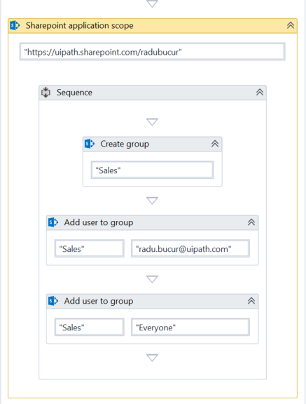

After the code above is executed on the groups page, we can find the following group:

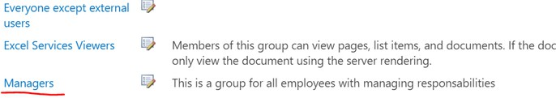

Inside, we can find the following users:

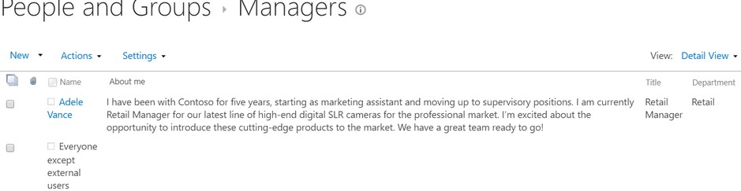

* 1. Remove User From Group

Removes a user from a specific group. This also works for removing AD groups from inside SharePoint groups. It is very similar to the **Add User to Group** activity.

An exception will be thrown if this activity tries to remove a user that is not part of the group.

* + 1. *Parameters*
       - **GroupName:** The name of the group we're removing the user from
       - **User**: The users email or "{domain}\{username}" or the name of an AD Group that needs to be removed from this group
  1. Get User

This activity helps you search for a user in SharePoint and returns the users ID and full details. It searches the user by either the email or the display name of the user.

This activity returns an exception if more than one user is found or if the search has 0 results**. It is recommended that users are searched by email address, this is far more reliable as their First Name + Last Name combination might not be unique.**

* + 1. *Parameters*
       - **User:** The email/name the user will be searched by.
       - **SharePointUser:** An **out** argument of type **Microsoft.SharePoint.Client.User** containing all the details of the user
       - **UserID:** An **out** argument of type **int** containing the ID of the found user
  1. Get All Users from Group

This activity allows you to get a list with all the users inside a SharePoint group. This is useful whenever we want to add/remove users to a group, since it can help us reduce the number of unnecessary queries done as well as preventing exceptions (since trying to remove a user which does not exist in a group can cause exceptions).

Using the GetAllUsersFromGroup activity will also give us all the relevant information about the users themselves.

This operation cannot be used if the QueryGrouping feature is enabled.

* + 1. *Parameters*
       - **GroupName:** A string containing the name of the group we want to retrieve the users for
       - **Result:** An **out** argument of type **List<Microsoft.SharePoint.Client.User>** containing all the users inside this group
    2. *Example*

Let’s assume I want to display to the console all the members of the **Sales** group inside my Site Collection.

If I navigate to the group's page, I will see the following members:

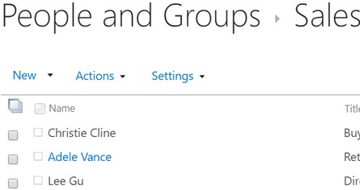

A workflow that retrieves the information of all these users from SharePoint and that displays it to the console, would look like this:

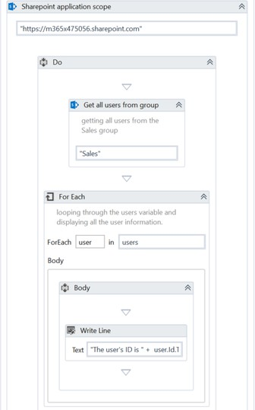

The Write line would retrieve the user information in the following manner:

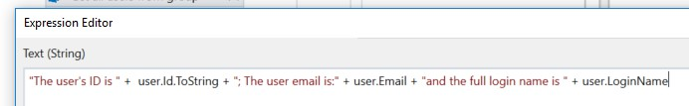

The result inside the console would be:



### SharePoint.Activities.Permissions

In order to provide access to our SharePoint content, we can assign permissions to groups or individual users at site, list/library, folder (or even item) level.

With our activities we can use all the permission levels SharePoint has:

* View Only
* Limited Access
* Read
* Contribute
* Edit
* Design
* Full Control

The following activities allow adding and removing permissions for:

* the SharePoint site itself
* a list
* a library
* or any folder inside a list/library

This is a set of activities which can be used in order to add and/or remove the permissions a group or an user has **in relation to a list or library or the current site**:

* AddPermission
* RemovePermission
* GetAllPermissionsFromGroup
  1. Add Permission

Adds a permission to specific group or user. This activity is compatible with the **QueryGrouping**

option.

* + 1. *Parameters*
       - **User/Group:** the name of the user or group we want to assign permissions to.
       - **Is User:** Select it if the assignee is a user and not a group
       - **PermissionToGive**: a dropdown that allows the user to select the permission level.
       - **ListName:** the name of the list/library we want to assign permissions to. **If this is left empty, the permissions will be assigned to the SharePoint Site instead**
       - **ListType:** this parameter needs to be used only when interacting with the permissions of a folder inside either a list or a library. It should be set to "Library" or "List" depending on the type of SharePoint collection we want to interact with.
       - **FolderPath:** the folder inside the list/library we want to assign permissions to. **If this is left empty, the permissions will be assigned directly to the list/library.**
         * This property can be used only if the ListName is not null

**Observation:**

SharePoint Online does not allow altering the permissions of the root site of a site collection, only the sub-sites can have their permissions changed. **Trying to either remove or add permissions to the root site of a site collection will result in an exception!**

* + 1. *Example*

Let’s assume that I have a sub-site in my SharePoint collection dedicated to the Sales team, a group named **Sales** which contains all the Sales Department employees and that I need to give them full control on that site.

I can do that very easily using the following workflow:

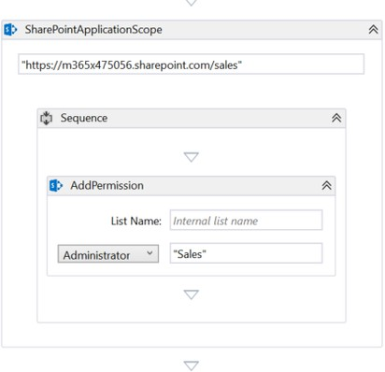

Notice that the List parameter is empty since the permissions are applied directly to the site. After I open the site's permission page, I will notice the following row:



* 1. Remove Permission

Remove all permissions a group or user has in relation to another list/library, its folder or even the SharePoint site.

This activity is compatible with the **QueryGrouping** option enabled.

* + 1. *Parameters*
       - **User/Group:** the name of the user or group we want to remove permissions for.
       - **Is User:** Select it if the deposed is an user and not a group
       - **ListName:** the name of the list/library we want to delete permissions from. **If this is left empty, the permissions will be removed from the SharePoint Site instead**
       - **ListType:** this parameter needs to be used only when interacting with the permissions of a folder inside either a list or a library. It should be set to "Library" or "List" depending on the type of SharePoint collection we want to interact with.
       - **FolderPath:** the folder inside the list/library we want to delete permissions from. **If this is left empty, the permissions will be removed directly from the list/library.**
         * This property can be used only if the ListName is not null
    2. *Example*

Let’s assume that I have a list called **TestList** where I have a folder **Sales Items** that we do not want to be accessible/visible to the users in the groups **Team Site Users** and **Teams Site Visitors**. We can achieve that by simply removing the permissions these 2 groups have on that folder.

The workflow that does this would look something like this:

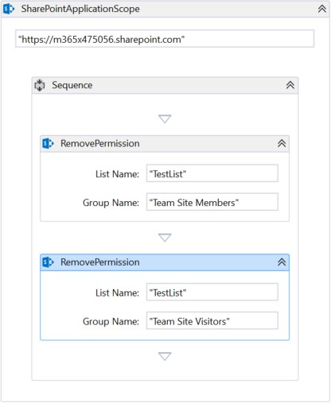

Note that both the Remove Permission activities reference the Sales Items folder in their

**FolderPath** argument:

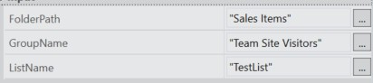

* 1. Get All Permissions

Gets all existing permissions a list/library, folder or even SharePoint Site has. This is very helpful if the user is trying to either add or remove any permissions in a SharePoint site, since it can help us reduce the number of unnecessary queries done as well as preventing exceptions (since trying to remove a permission which does not exist for a group can cause exceptions).

This activity is not compatible with the **QueryGrouping** option enabled.

* + 1. *Parameters*
       - **ListName:** the name of the list/library we want to delete permissions from. **If this is left empty, the permissions will be removed from the SharePoint Site instead**
       - **FolderPath:** the folder inside the list/library we want to delete permissions from. **If this is left empty, the permissions will be removed directly from the list/library.**
         * This property can be used only if the ListName is not null
       - **ListType:** this parameter needs to be used only when interacting with the permissions of a folder inside either a list or a library. It should be set to "Library" or "List" depending on the type of SharePoint collection we want to interact with.
       - **Result:** an **out** argument of type List<Tuple<string,string>> which contains a full list with all the permissions on the specified SharePoint object

#### if the entity that has this permission is a user then the first value in each tuple contains the full login name of the user (The full login name is a bit ugly but usually has an easily identifiable format!)

* + - * + **if the entity that has this permission is a group** then the first value in each tuple **contains the group's name**
        + the second value of each tuple contains the permissions name

**Observation:**

If an entity has multiple permissions, we will have a tuple for each one of them in the output list!

* + 1. *Example*

Let’s assume I want to display all the permissions my users have on the **Sales Items** folder in my **TestList.**

Below we can see the folder:

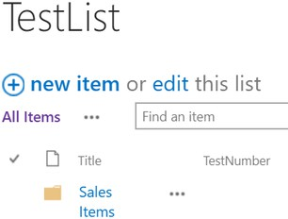

If I navigate to folders permission page, I can see there are plenty of permissions assigned to it (some inherited from the parent list and some assigned specifically to it, it doesn't matter, they will all be retrieved):

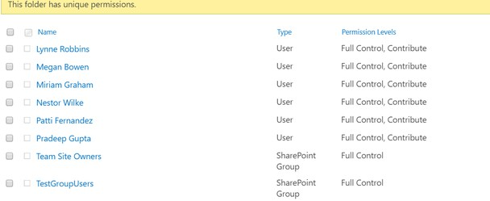

Using the following workflow, I can Retrieve and display to the console all these permissions:

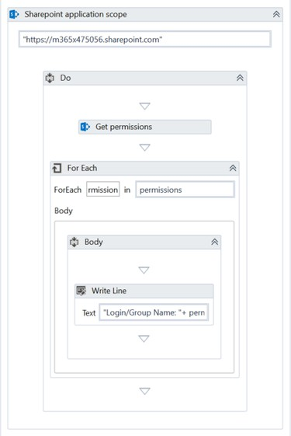

The arguments my Get Permissions activity will have are the following:

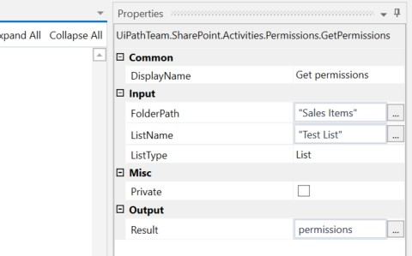

The Write Line will access the properties in each tuple the following way:

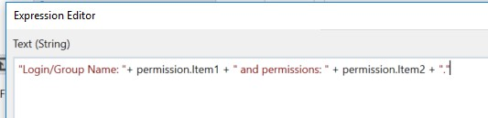

The console output will be:

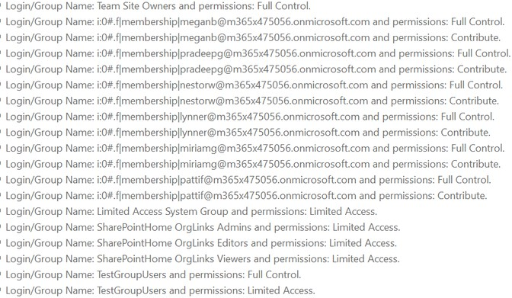

### Sign Out

When you need to sign out the current user, you can do so either by selecting the **“Reset Credentials”** checkbox in the SharePoint Application Scope activity (which logs out the current user before prompting a form for the user to introduce other credentials to use for login) or by using the Sign Out activity, which signs out the current user whenever you need it.

**The activity should be used only in case you are signed in to a WebLogin SharePoint Instance!** Signs out the current user! In case of Multifactor Authentication, the user might remain logged in for some time; if we need to log in a different user, we have to sign out the current one.

* 1. *Parameters*
* **URL:** The URL of the SharePoint site we want to sign out from
  + We need it because the activity clears the cache created for the URL when the user signed in (the cookies that keep the user logged in)
  + The activity doesn’t need to be placed inside the SharePoint Application Scope,

however the URL is mandatory when it is outside a Scope activity

### Get Web Login User

Gets the current user in case you are signed into a **WebLogin** SharePoint Instance. For Multifactor Authentication, the user remains logged in for some time (unless you specifically sign it out), so it can be useful to check what user is currently logged in, in case you might need to sign them out.

* 1. *Parameters*
* **URL:** The URL of the SharePoint site our user is signed in
  + We need it because the activity checks the cache created for the URL when the user signed in (the cookies that keep the user logged in).If there are cookies exist, then we have a user logged in. If not, there is no user logged in and the activity will return a null object
  + The activity doesn’t need to be placed inside the SharePoint Application Scope, however the URL is mandatory when it is outside a Scope activity
* **SharePointUser:** an **out** argument that returns a User object if we have a user logged in, or null otherwise

### Get TimeZone

Retrieves the Time Zone of the SharePoint site. It’s useful when processing DateTime parameters from SharePoint as it tells the user what’s the TimeZone set for their site.

* 1. *Parameters*
* **SharePointTimeZone:** an out argument that returns a Microsoft.SharePoint.Client.TimeZone object containing information about the site’s TimeZone

# Query Grouping

The **QueryGrouping** option is a feature which allows the users to group up repetitive queries in batches, so that they are processed more efficiently. Instead of simply sending each query individually to the server and waiting for the response to be received, the scope activity just stores all the queries and sends them after all the children activities got executed resulting in a more efficient processing time.

However, this is only possible for the following activities: **AddListItem, AddPermission, RemovePermission, AddUserToGroup, CreateGroup, DeleteGroup, RemoveUserFromGroup.** F or the rest of the activities it would either not make sense (it does not make sense to use the **Get List Items** activity in an async way since it would not be able to return the items, or the **EditListItems** activity since it only uses 1 query to update multiple items ) or it is not possible since some activities require multiple queries executed one after another in order to perform one action.

As it was mentioned before, the QueryGrouping feature can be enabled by clicking the

**QueryGrouping** Checkbox in the SharePoint Scope Activity:

c880d5a9f58fe5b6189a3e499bfd9376

**Observation:**

Depending on the size of the data we might try to send to the server at once, the request might receive the following exception: **"The request message is too big. The server does not allow messages larger than XXXXX bytes."**

In order to avoid that, for queries that send a large amount of data to the server, the number of queries inside a SharePoint Scope should be limited (a good example can be seen below).

If this feature is enabled and the user tries to add an activity that is not supported, a validation message will appear.

## Example

Let’s prepare a small example in which we need to add all the rows from an excel file to our SharePoint list (called **TestList**), assuming that our file has hundreds of rows, adding them one by one would take a lot of time so in order to speed up the creation of the list items, we will try to add them 100 at a time.

The list we'll add everything on:

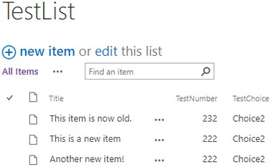

The contents of the excel file (in total 211 rows):

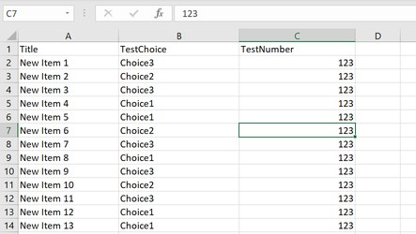

The full example with explanatory annotations can be found here (SharePoint Login Data removed, of course).



SharePoinQueryGroupingTest.zip

# Prerequisites

* Have access to an instance of SharePoint and an account with all the

necessary permissions. **You will not be able to use this package using your credentials**

#### to do any operations that you couldn't do on your SharePoint environment in the browser.

* This solution might not work if your SharePoint instance is using a 3rd party Identity Provider.

# Observations

* Make sure that when you are working on a SharePoint site **you use the correct URL** in the SharePoint scope and not the URL of a parent site and/or of a sub-site.
* Keep in mind that the **QueryGrouping** option is only available for some activities (mentioned previously). For any activity that has Out Arguments and it is used with the query grouping feature enabled, it will have those arguments return **null.**
* For all List Activities using list fields, we must reference these fields using their **Internal Name,** not their title (often enough, they are not the same). In order to obtain the internal name of a field open the list settings, click the field and look at the URL of the page, the internal name will be there:



* If you want to assign a value to field specific field for a list item, **first make sure that field exists inside your list** (otherwise create it).
* Since giving permissions to users directly is a bad practice, **we only allowed the assignation and removal of permissions to and from groups only. This package does not allow the assignation and/or removal of permissions from users directly!**
* **Each time you alter the permissions of an object, you will break the inheritance of permissions from its parent element. This means that if the permissions of the parent are changed, the changes will not be reflected on the original element.** Try to be careful of the scope of the permissions you assign and always assign permissions to the highest suitable scope.
* Some of the activities (GetAllUsersFromGroup, GetUser or some of the list items using more advanced data fields) can use types and classes that are specific to the **Microsoft.SharePoint.Client** if you are having issues with these types, please make sure that this namespace is added inside the imports Tab:

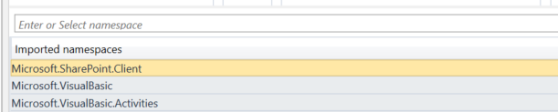

* We provided plenty of detailed examples so if you're having any issues using this package, make sure to consult the examples.
* If the metadata needs to be edited for Files, the **Update List Items** Activity can be used on the parent library!

# Technical Approach

This package is mainly built using the .NET **Client Side Object Model** (CSOM) which contains a large number of object representing SharePoint objects which can be used in order to make changes and retrieve information from the SharePoint site. Since CSOM is very similar for all different types of SharePoint instances, we can use the same set of activities for both SharePoint Online and SharePoint OnPremises.

Another advantage is that we can choose the moment we send the queries created so far to the server, so in some cases we can group them up and send them together to the server, therefore increasing the efficiency of the package.

Additionally, CSOM can leverage the Collaborative Application Markup Language (CAML) which is a very powerful XML-based language that can be used to create extremely detailed and complex queries on SharePoint Lists. These queries greatly increase the versatility of the activities and the big advantage is that several 3rd party tools can be used to generate CAML queries without the user having any previous knowledge of this language.

In some places, the REST API of the SharePoint instance is used in order to download and/or upload documents in order to avoid issues regarding the size of documents.

In order for the package to offer the possibility of Multifactor Authentication Login, we are using OfficeDevPnPCore, which is the PnP Core Component of the CSOM Library, created by Microsoft and community members to offer CSOM extension methods for SharePoint.

Below you can find more info regarding:

1. CSOM and SharePoint REST API: [https://docs.microsoft.com/en-us/sharepoint/dev/sp-](https://docs.microsoft.com/en-us/sharepoint/dev/sp-add-ins/sharepoint-net-server-csom-jsom-and-rest-api-index) [add-ins/sharepoint-net-server-csom-jsom-and-rest-api-index](https://docs.microsoft.com/en-us/sharepoint/dev/sp-add-ins/sharepoint-net-server-csom-jsom-and-rest-api-index)
2. CAML: [https://docs.microsoft.com/en-us/sharepoint/dev/schema/collaborative-](https://docs.microsoft.com/en-us/sharepoint/dev/schema/collaborative-application-markup-language-caml-schemas) [application-markup-language-caml-schemas](https://docs.microsoft.com/en-us/sharepoint/dev/schema/collaborative-application-markup-language-caml-schemas)
3. SmartCAML (3rd party tool that can generate CAML query

syntax): <https://www.microsoft.com/en-us/p/smartcaml/9nn8gjpnxvfg>

1. OfficeDevPnP ([https://docs.microsoft.com/en-](https://docs.microsoft.com/en-us/dotnet/api/officedevpnp.core?view=sharepointpnpcoreonline-2.18.1709.0) [us/dotnet/api/officedevpnp.core?view=sharepointpnpcoreonline-2.18.1709.0](https://docs.microsoft.com/en-us/dotnet/api/officedevpnp.core?view=sharepointpnpcoreonline-2.18.1709.0))